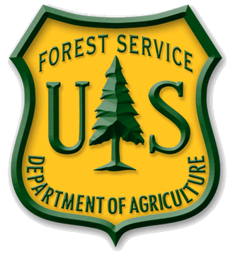
News Release

USDA Forest Service

Coronado National Forest
www.fs.fed.us/r3/coronado

Effective Immediately CONTACT: Heidi Schewel (520) 388-8484
For News Media Use Only

ROSEMONT COPPER PROJECT UPDATE

Analysis Continues for Environmental Impact Statement

Tucson, AZ (November 16, 2012) – The Coronado National Forest planned to release the Rosemont Copper Project Final Environmental Impact Statement (FEIS) for public review in December, 2012. However, additional work must be completed before a decision is made and the Record of Decision issued, so the FEIS will not be available at that time.

The additional work that must be completed includes consultation with the U.S. Fish and Wildlife Service; consultation with tribes and the State Historic Preservation Office; Army Corps of Engineers permit coordination; updating of air quality models; additional transportation analysis; integration of updated lighting mitigation plans; evaluation of socioeconomic impacts to the astronomy industry in southern Arizona; and consultation with the Forest Service Southwestern Regional Office.

Exact dates for release of the FEIS are difficult to predict and depend on completion of the consultation and additional effects analyses. The Coronado will continue to anticipate project timeframes and keep the public apprised and informed.

In the process to refine project alternatives and mitigate impacts, the Coronado requested Rosemont reconsider various aspects of their operations. This request was based, in part, on several of the more than 25,000 comments received on the October, 2011 Draft Environmental Impact Statement. Rosemont’s August 2012 Feasibility Update Report reflects environmental and operational refinements, such as addressing groundwater quality concerns and improvement of storm water management for the benefit of downstream resources.

New information resulting from Rosemont’s Feasibility Update Report will be reviewed and considered as the CNF continues its ongoing analysis.

The USDA Forest Service is an equal opportunity provider and employer.

